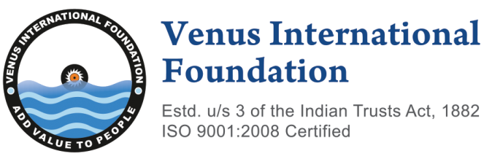 | A Non-Profit Organization  GSTIN: 33AABTV9686L1ZN  E–mail: contact@venusinfo.org  Phone: 044 – 22531502  Mobile: +91 9840556456
No.1, Ganesh Nagar Main Road, Adambakkam, Chennai – 600088, Tamilnadu, India

9th Venus International Healthcare Awards – VIHA 2026 (Official Nomination Form)
5 December 2026 at Green Park, Chennai, India | https://venusinfo.org/medical/2026/ahs.html
Section – I: Personal Information
1 | Name of the Applicant
2 | Gender
3 | Date of Birth and Age
4 | Place of Birth and Country of Birth
5 | Nationality and Citizenship
6 | Marital Status
7 | Primary Email Address
8 | Secondary Email Address
9 | Mobile Number
10 | Educational Qualification (Completed)
11 | Years of Experience
Section – II: Specialty (Refer clause 3 and 5 of Policy Document)
1 | Specialty
2 | Research Focus
3 | Award Category
Section – III: Current Employment
1 | Name of the Hospital/Institution
2 | Postal Address of the Hospital / Institution
3 | Website of the Hospital / Institution
4 | Date of Joining in Hospital / Institution
5 | Department / Division
6 | Present Designation
7 | Nature of Appointment (Permanent / Contract )

DECLARATION

I hereby declare that I have carefully read the CLAUSE 8 of the policy document of VIHA 2026 and agreed to the same. I confirm that to the best of my knowledge, the information given in this nomination form is correct and complete. At any time I am found to have concealed/distorted any material, information, my nomination shall be liable to be summarily terminated without notice/compensation.
I agree to VIF to process the data submitted in this nomination form, or any other data that the foundation may obtain from me for any purposes connected with VIHA or AHS 2026 or for any other legitimate reason.

Date: Place: Scanned Signature of Applicant

ANNEXURE – I

- Submission (Clause 10 of the Policy Document)
List of documents to be submitted
- The filled nomination form in pdf/.doc/.docx format
- Duly completed curriculum vitae (of any format/pages)
- Recent photograph
- Copy of degree certificate (PG or PhD or Equivalent)
- Copy of registration certificate (s)/ license (s) if applicable
- Copy of workplace ID

Nominee has to submit the filled form and other necessary documents electronically to:
viha2026@venusinfo.org (AND) directorvifindia@gmail.com

Note:
The VIHA 2026 no longer requires a hardcopy of the Nomination Form.
- B. The Secretariat
The General Chair – 9th Annual Healthcare Summit (AHS 2026),
Center for Health and Medical Sciences,
Venus International Foundation,
No.1, Ganesh Nagar Main Road, Adambakkam, Chennai – 600088,
Tamilnadu, India.
Ph: 044 – 22531502

ANNEXURE – II

- A. The VIHA 2026 Selection Process (Clause 8 of the Policy Document)
This section describes VIHA 2026 Selection Process

8.1 | Preliminary assessment / Screening
8.2 | Acknowledgement intimation to the nominee
8.3 | VIHA team may ask proof for credits mentioned in the cv (optional)
8.4 | Cross verifying the documents and forwarding it to the committee
8.5 | Selected nominees will be communicated with an official email
8.6 | AHS 2026 Registration (Refer Annexure – B of the Policy Document)
8.7 | Release of the winners list in an official webpage
8.8 | An official invitation email will be communicated to the award winner
8.9 | Award presentation ceremony
8.10 | Summary of AHS 2026 will be released in an official webpage

- B. The Committee
Dr. R. Sathishkumar
General Chair (chairman@venusinfo.org)

Mrs. M. S. Sudha
Program Chair (+91 9840556456 | director@venusinfo.org)

Mrs. K. Nanthini
Program Co-Chair (contact@venusinfo.org)

Mrs. A. Sara
Publications Chair

Mrs. S. Sumithra
Publications Co-Chair

